5 Real-World Student Accommodation Finder Websites/Apps.
- ONSA (One National Student Accommodation)⁠
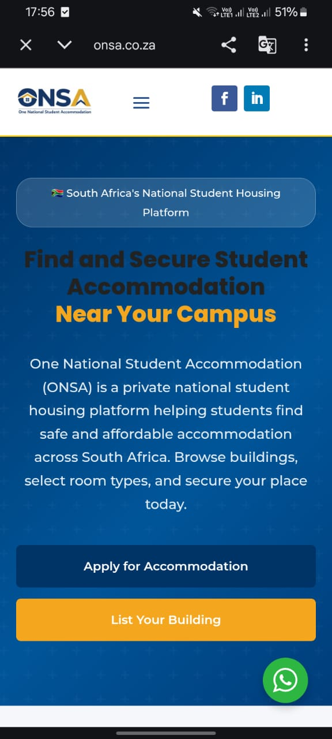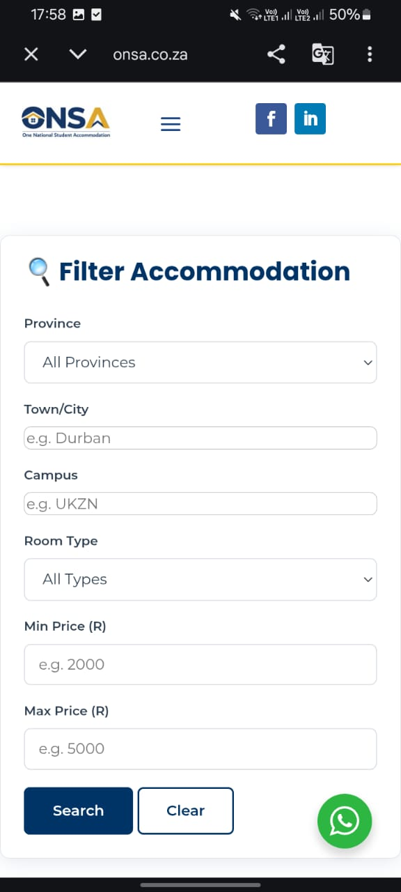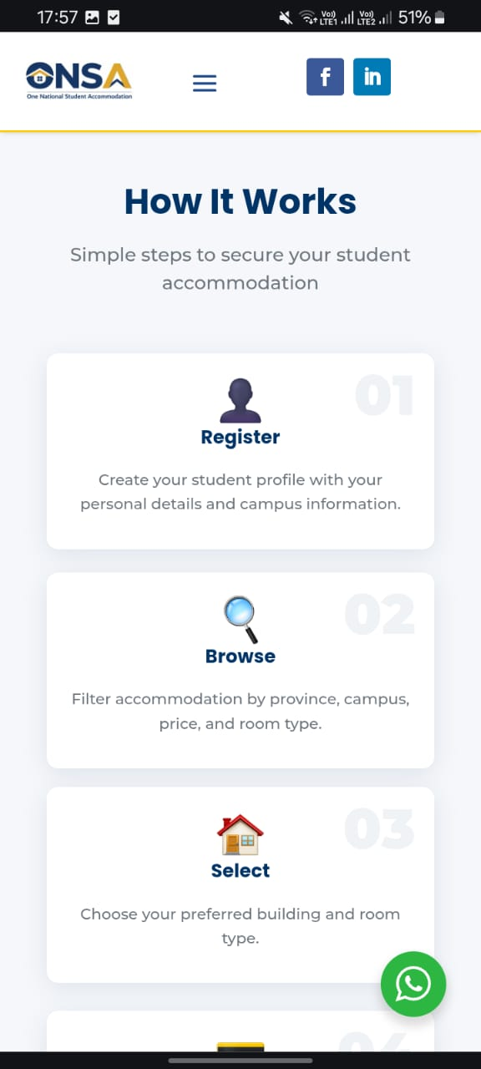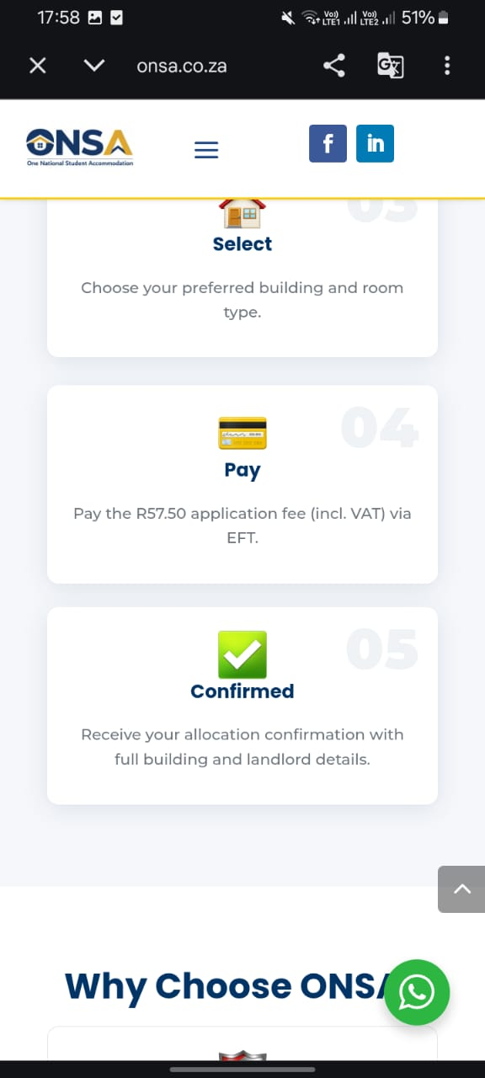

What do they do well?
Verified landlords, easy registration, secure payments, nationwide coverage
What do they do bad?
Application fee may discourage some students; limited extra student services.
onsa.co.za
URL: https://onsa.co.zawsa
Author: ONSA.
Date accessed: 12 July 2026

2.Dwell
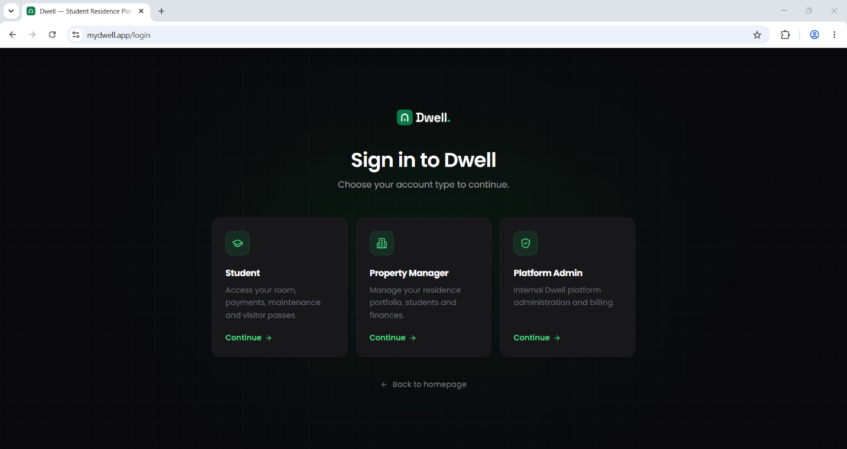
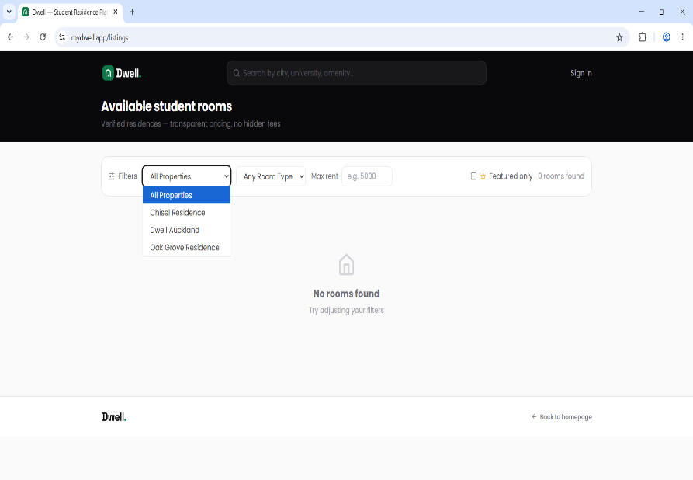
What do they do well?
Modern interface, verified residences, maintenance and payment management, student portal.
What do they do bad?
Focuses mainly on managed residences rather than offering many accommodation choices. �
URL: https://mydwell.app⁠�
Author: Dwell.
Date accessed: 12 July 2026
mydwell.app
3.ResiFind

What do they do well?
Verified listings, SOS safety feature, free student access, simple application process.
What do they do bad?
Availability may vary depending on university or city. �
ResiFind
URL: https://www.resifind.co.za⁠
Author: ResiFind.
Date accessed: 12 July 2026
4.OffCamp⁠�
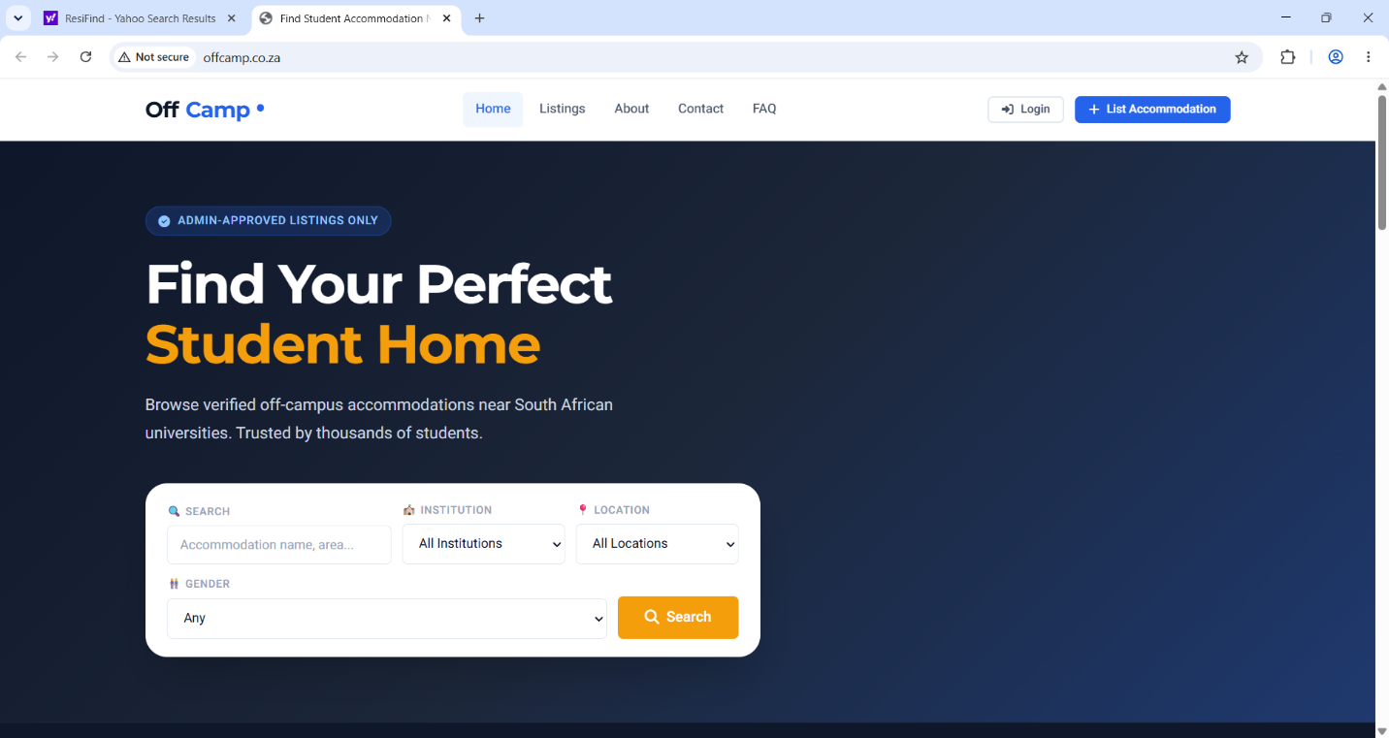
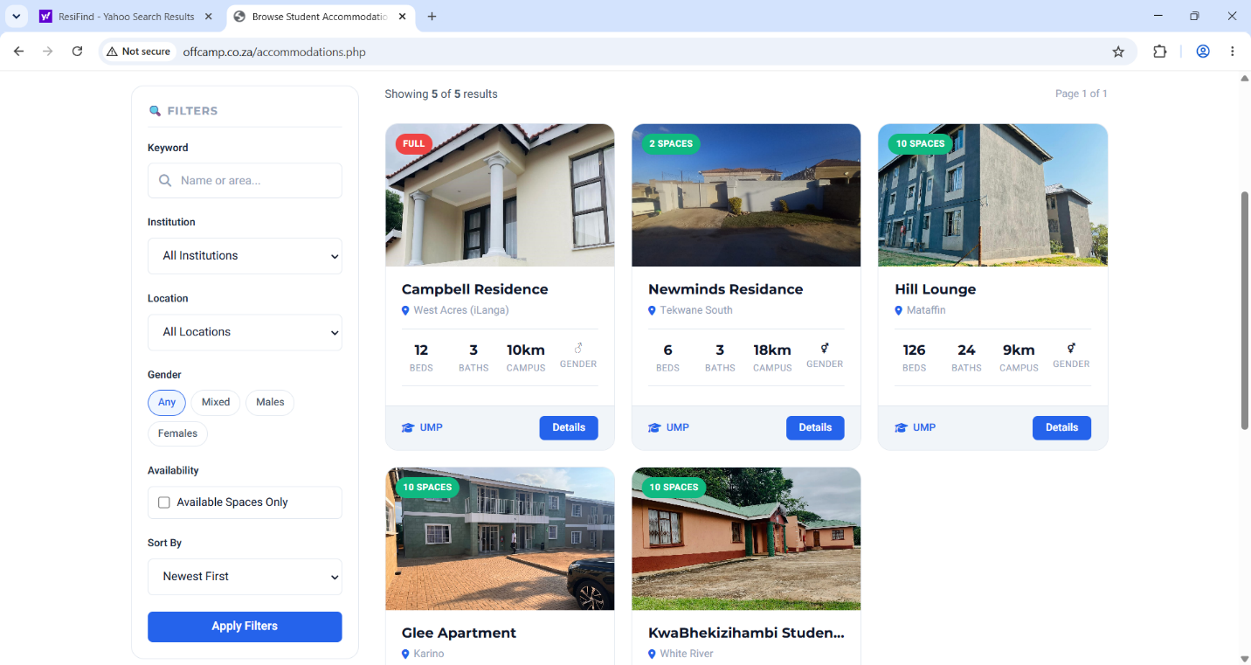
What do they do well?
Direct landlord contact, smart filters, verified listings.
What do they do bad?
Covers fewer universities than larger competitors. �
offcamp.co.za
URL: https://www.offcamp.co.za⁠�
Author: OffCamp.
Date accessed: 12 July 2026
5.UniHub
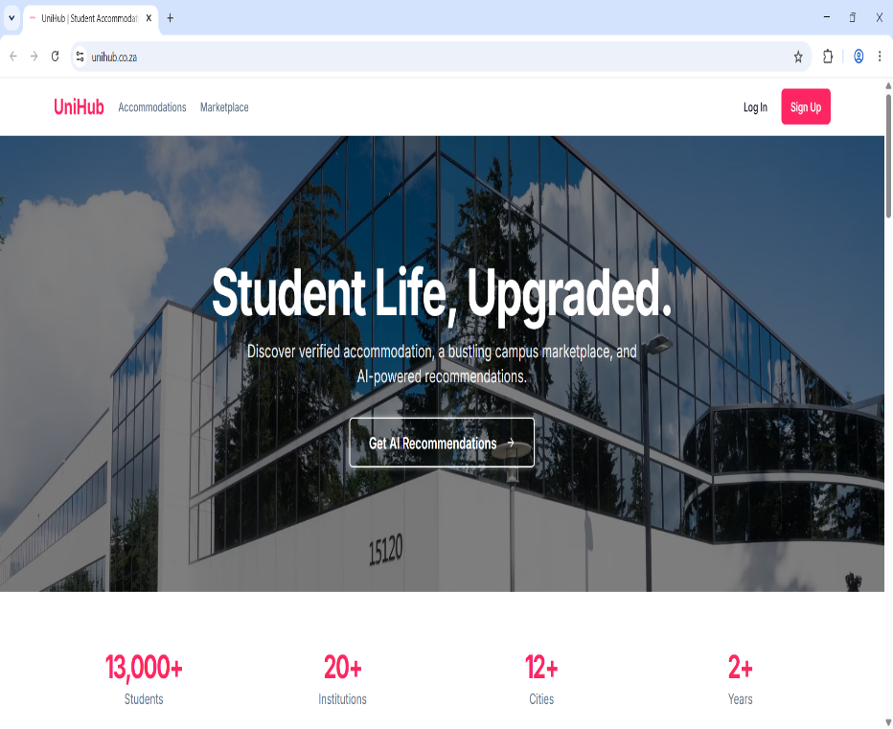
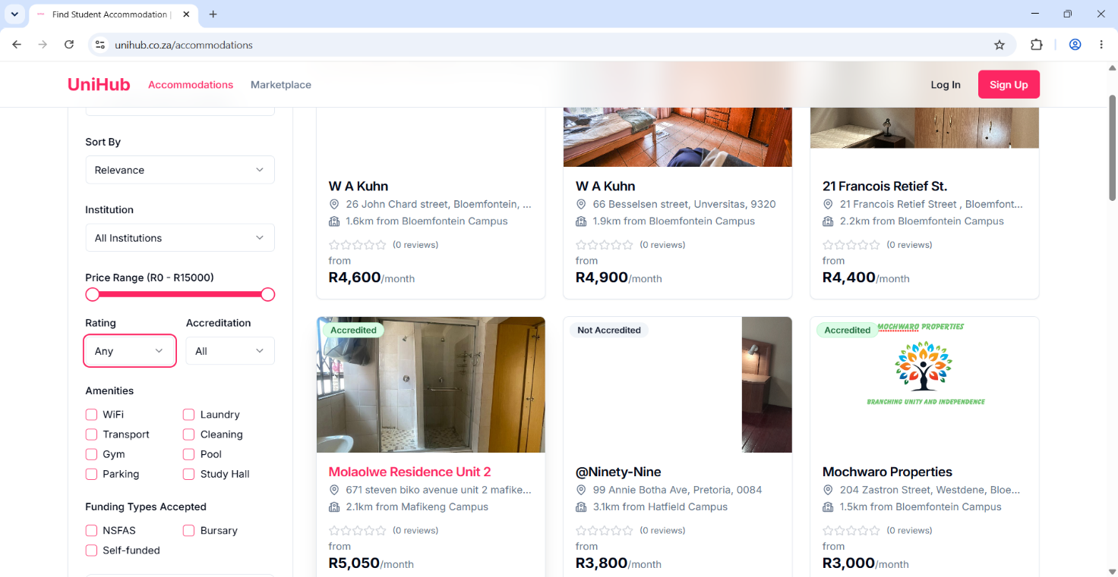
What do they do well?
Combines accommodation with a student marketplace, AI recommendations, verified listings.
What do they do bad?
Newer platform with fewer accommodation listings in some areas. �
unihub.co.za
URL: https://unihub.co.za⁠�
Author: UniHub.
Date accessed: 12 July 2026

